Roland Cheremeh

Harrisburg university of Science and technology

1. What are the two phenomena that happen when the light hits an object?

* The surface becomes shaded.
* Objects cast shadows on the ground.

1. What are the two things you need to consider when talking about shading?

* The type of light source that is emitting light.
* How the light is reflected from surfaces of an object and enters the eye.

1. What are the three different types of light? Make sure to give an example of each.

* Directional light, e.g., the sun
* Point light, e.g., a light bulb.
* Ambient light, e.g., light reflected by walls or objects.

1. Explain the difference between diffuse and ambient reflection.

Diffuse reflection refers to reflecting light falling on a surface from a directional light such as the sun or a point light such as the bulb. In contrast, ambient reflection refers to the reflection of light emerging from another source of light. Moreover, in diffuse reflection, scattering of light is the same in all directions from the point where it strikes the surface, while for ambient reflection, reflection occurs at the same angle as that of incoming light. Additionally, ambient reflection has the same brightness at any position because ambient light shines on an object equally from all directions, but for diffuse reflection, reflected light has the same intensity at a given point since light is scattered equally in all directions after it bounces off the surface.

1. Explain the role of the cos⁡θ in the following **diffuse reflection** formula

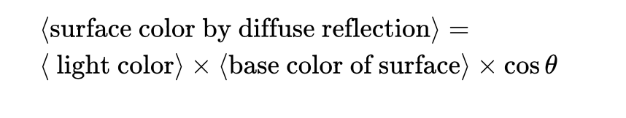

The role of $CosƟ$ in the equation is to show that surface color is directly proportional to the angle between the reflecting surface and the direction of light.

References

https://developer-mina.gitbook.io/cisc-400/module-07/lighting-objects